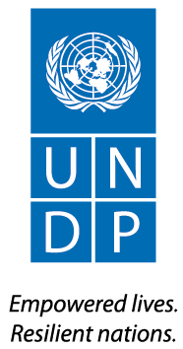

Ref: UNDP/
21 January 2026
Dear Sabancı Foundation,

Subject: Project “Young Women Building Their Future Phase II – NEET Women Phase II”
Progress Report

Reference is made to the contribution agreement between Sabancı Foundatipn and UNDP for the project “Young Women Building Their Future Project Phase II” effective [01 July 2025].

I am pleased to submit herewith the Progress Report for the abovementioned project.

The report summarizes the progress of the project between July 2025 and December 2025 and provides an overview of the achievements, challenges, lessons learned, interim financial status and way forward.

I thank Sabancı Foundation for its contributions to UNDP and look forward to strengthening our partnership in support of development in Turkey.

Monica Merino Domínguez
Resident Representative
UNDP Türkiye

Attached:
Young Women Building Their Future – NEET Women Progress Report

Nevgül Bilsel Safkan
General Manager
Sabancı Foundation
İstanbul, Turkey

Reporting Period | July 2025 – January 2026
Donor | Sabancı Foundation
Country | Turkey
Project Title | Young Women Building Their Future Project Phase II – NEET Women Phase II
Project Locations | Ankara, İstanbul, Bursa, Afyonkarahisar, Gaziantep, Samsun
Project ID  (Atlas Award ID)  Outputs  (Atlas Project ID and Description)  Strategic Plan and/or CPD Outcomes | 01004298
Implementing Partner(s) | Ministry of Family and Social Services, Ministry of Labour and Social Security
Project Start Date | 01/07/2025
Project End Date | 31/03/2027
LPAC Date | 25/02/2025
Steering Committee/Project Board Meeting Dates | 22.12.2025
SDG linkages | SDG 5.5, SDG 8.6, SDG 10.2
GEN marker | GEN 3
2025 Delivery to Budget Ratio | 16,65% (133.170,44)
2025 Annual Work Plan Budget | 40,62% (324.978,50)
Total resources required | 800.000,00 USD
Revenue received | Regular USD  • Other  o Donor 800,000 USD  o Trust Fund Cost Sharing USD  o Thematic Trust Fund C/S USD  o Special Activities USD  o EU funding USD  • Total 800,000 USD
Unfunded budget | N/A
UNDP Contact Person | Monica Merino  Resident Representative  UNDP Turkey  Email: monica.merino@undp.org

Executive summary

The second phase of the Young Women Building Their Future Project, implemented in collaboration between the Ministry of Family and Social Services and the Ministry of Labor and Social Security, the United Nations Development Programme (UNDP), and the Sabancı Foundation, commenced in July 2025 and is planned to be completed by the end of March 2027.

The second phase of the project aims to develop best practice examples and mechanisms to increase the employability of young NEET women aged 18-35. Within this framework, the goals are to increase awareness and empower NEET women by enhancing the capacities of stakeholders at local, national, and global levels and strengthening collaborative networks among stakeholders, improving the competencies of NEET women and increasing employment opportunities for them, and raising awareness of NEET women in society.

For project management, in addition to the Project Manager of the first phase, the recruitment process of 1 Project Assistant was completed by UNDP. The UNDP Project Team is also supported by the Gender Analyst and the Communication Team of UNDP. A Project Technical Team and a Project Management Team consisting of UNDP, SV, MoFSS and MoLSS representatives was established to carry out and monitor the project activities and share the project progress.

The first Project Steering Committee Meeting was held on 22 December 2025, with the participation of the Project Management Team and the representatives of Presidency of Strategy and Budget (EV 1).

In the scope of Output 1

A nationwide Stakeholder Mapping Report was prepared based on responses from 250 public institutions, identifying key employment sectors and highlighting the multidimensional needs of NEET women, underscoring the need for a holistic approach integrating education, employment, and social support.

In the 6 pilot provinces, 8 consultation meetings were held to assess cooperation opportunities with local and national stakeholders, identifying potential partnerships for employment-oriented trainings and well-being support services. Within the Career Counselling Programme, cooperation with İŞKUR was established, and capacity-building trainings were delivered to Job Club Leaders and Ministry staff on 13–15 January 2026. In addition, various capacity development activities were planned to raise awareness and improve service quality at the local level.

To strengthen international visibility and knowledge sharing, the project participated in international platforms and events, and the English version of the White Paper on NEET women was published online (https://geleceginikurangenckadinlar.org/kutuphane/).

In the scope of Output 2,

During the second phase of the project, comprehensive capacity-building activities were implemented to enhance the employability and empowerment of NEET women through online, face-to-face, and hybrid trainings. Programmes focused on vocational, digital and green skills, future skills, psychological resilience, access to rights, and job application competencies.

Key activities included a Certified Online Human Resources Training Programme attended by 23 NEET women; face-to-face trainings such as the Life-Enriching Encounters Training in Adana, Job Application Skills Training in cooperation with Akçansa, and the Artificial Intelligence and Data Science Development Programme for Women (Istanbul). In addition, mentees participated in digital skills trainings under the Future of Work Academy: Skills Sprint 2025, and preparations were initiated for digital skills trainings at Digital Youth Centers in Bursa and Gaziantep.

Within the Mentorship Programme, 499 mentee–mentor matches were established and 1,473 mentoring sessions were conducted. Eight training-of-trainers sessions and additional mentee trainings were delivered, resulting in 65 NEET women taking initial steps toward employment or work experience.

Under the Career Counselling Programme, services were planned to be delivered through İŞKUR Job Clubs in pilot provinces. As a pilot, an online career counselling programme was implemented with Adecco, through which 304 NEET women received CV support, 66 participated in one-on-one HR interviews, and 28 were referred to job opportunities.

In total, 49 trainings were organized during the second phase, reaching 2,007 NEET women. Due to multiple participations, the total number of unique participants reached was 2,198. Overall, 68 NEET women were supported in accessing employment through training, mentorship, and career counseling activities.

Trainings:

- 04 July 2015 – Job Search, Interview Skills and CV Preparation Training: 33 participants
- 16 July 2015 – Psychological Resilience Training: 52 participants
- 06 August 2025 – Emotional Awareness and Self-Compassion Training: 86 participants
- July 2025 (1–31 July 2025) – Ada Lovelace Academy Digital Skills Training Programmes: 1,109 participants
- 22 August 2025 – Self-Confidence Training: 21 participants
- 03 September 2025 – Communication and Conflict Management Training: 19 participants
- 15 September 2025 – Preparing for Working Life: Effective Learning Methods Training: 22 participants
- 22 September 2025 – Access to Women’s Rights Training – Module 1: 30 participants
- 01 October 2025 – Access to Women’s Rights Training – Module 2: 13 participants
- 06 October 2025 – Discovering Strengths and Future Design Training: 8 participants
- 13 October 2025 – Gender Equality Training: 8 participants
- 21 October 2025 – Access to Women’s Rights Training – Module 3: 29 participants
- 31 October 2025 – Sustainability Training: 44 participants
- 05 November 2025 – Digital Transformation Training: 93 participants
- 29 September 2025 – 17 October 2015 – Ada Lovelace Academy Digital Skills Training Programmes: 524 participants
- 8 October 2025-5 November 2025 –Hayat Dolu Buluşmalar: 15 participants
- 14 November 2025 – Workplace Basic Principles and Rights Training: 61 participants
- 17 November 2025 – Job Application Skills Training:8 participants
- 17 November 2025- 12 December 2025 – Human Resources Certificate Program: 23 participants

In the scope of Output 3,

A range of communication and advocacy activities were carried out to raise public awareness on NEET women and to enhance the visibility of the project. Through content shared on UNDP’s social media accounts, a wide audience was reached across multiple platforms, including Instagram, LinkedIn, X, and Facebook, achieving high viewership figures.

The seven stakeholder consultation meetings organized in the pilot provinces contributed to local-level awareness by facilitating discussions on existing and potential interventions for NEET women. In addition, the project was represented at two international events—Istanbul Development Dialogues 2025 and Future of Work Academy: Skills Sprint 2025—thereby increasing the international visibility of efforts targeting NEET women.

Background Information

The NEET concept, which stands for Not in Education, Employment, or Training, is used to highlight the challenges faced by young people who are excluded from these essential areas. Despite its importance, detailed information and comprehensive research on NEETs are limited. Youth unemployment, both globally and in Türkiye, has been on the rise, exacerbated by the COVID-19 pandemic, which has led many young people to lose jobs or training opportunities. Studies indicate that educational disadvantage and dissatisfaction are the two primary risk factors for becoming a NEET. These issues, when combined with social factors like family background, school environment, and personal characteristics, negatively impact youths' attitudes toward education. Educational disadvantage is often linked to broader domestic issues such as parental unemployment, high regional unemployment, special education needs, chronic illness, or disability. Education level significantly influences NEET status, with young people having lower education levels being twice as likely to become NEET compared to those with secondary education, and three times more likely compared to those with higher education.

Being a result of long-standing structural problems in Türkiye, youth unemployment, has been deepened since access to decent jobs became more difficult due to the pandemic. However, not only youth unemployment is increasing; also the group that gives up looking for a job by losing hope of working is growing (discouraged workers). One of the factors of low youth employment and education is assessed to be limited access to vocational training in Türkiye. The unemployment rate of the young population between the ages of 18-29 is 15.9% and the rate of young people who are neither in education nor in employment (NEET) is 30.3%, making Türkiye one of the countries with highest NEET figures among OECD members. 43.4% of young women in Türkiye are NEET (Turkstat, 2024). The number of women between the ages of 18-29 who have graduated from vocational high school at least two years ago and who are not looking for a job, exceeds one million. It is estimated that young women are more likely to be NEET than men with a gap of 25.7 percentage points in the case of Türkiye (Turkstat, 2024). There are several factors contributing to stickiness of the status for women, in addition to those applicable for both NEET women and men: early marriages and pregnancies, establishment of the role of homemaker, difficulties for adjudicating between requirements of family and work. Stickiness of the status also hints at the shortness of the period of time that can be put into use for pulling women out of the NEET category, therefore high marginal value of time and necessity of urgent and timely action.

As in the UNDP Strategic Plan, Sustainable Development Goal (SDG #5) is dedicated to “gender equality”. This is also a cross-cutting issue, as empowerment of women and girls makes crucial contributions to the progress across all the SDG’s and targets.

The Project is planned to contribute to the following SDGs:
SDG #5 Gender Equality: Achieve gender equality and empower all women and girls. (5.5)
SDG #8 Decent Work and Economic Growth: Promote sustained, inclusive and sustainable economic growth, full and productive employment and decent work for all. (8.6)
SDG #10 Reduced Inequalities: Reduce inequality within and among countries. (10.2)
SDG #16 Peace and Governance
SDG #17 Partnership for the Goals.

Discussions and initial project implementation results indicate that addressing the NEET problem requires more than just focusing on the target group. Contributing factors include caregiving responsibilities, skill mismatches, unequal training opportunities, cultural barriers, and an unprepared business environment, all of which significantly impact youth unemployment, especially among young women. Consequently, this project is designed based on these lessons learned to provide a platform for implementing models that can contribute to solving these issues.

Progress Review

UNSDCF 2021-2025 Outcome 2.1 is stated as: “By 2025, public institutions and the private sector contribute to more inclusive, sustainable, and innovative industrial and agricultural development, and equal and decent work opportunities for all, in cooperation with the social partners.” The project was structured on the cooperation of public, private, academia and NGOs to cover all related part to ensure equal and decent work opportunities for women. From the beginning of the project, all related parties were invited to the activities of the project. A stakeholder mapping report was initiated with the support of the Ministry of Family and Social Services to identify existing and planned services for women’s empowerment across Türkiye. The activation of the advisory board established in the first phase was planned. The first Project Steering Committe Meeting was held for increasing the impact of project. Partnerships with local stakeholders in the pilot provinces have been initiated to ensure effective coordination and collaboration in the implementation of project activities. In parallel, the planning and design of both face-to-face and online capacity-building trainings to be delivered in the pilot provinces have commenced. Following the completion of these trainings and activities, the project aims to support the labour market integration of unemployed and uneducated women by enhancing their employability and ameliorate the quality of the services provided to NEET young women.

CPD Outcome 2.3 is stated as: “Capacities strengthened to raise awareness on and to fight structural barriers to women’s economic empowerment” with the specific indicator 2.3.1 which is “Number of partnerships raising awareness to remove barriers in front of women's economic empowerment”. The activities to raise the awareness of both women and the public are in progress to be developed with the related partners. Online meetings were held with local stakeholders to give information about the project and consult with them on possible collaborations at the local level. Following these meetings, field visits will be planned to plan upcoming project activities with local stakeholders in pilot provinces. Capacity-building training was provided to İŞKUR Job Club Leaders and Family and Social Services Provincial Directorate personnel as part of the online career counseling program.

In the scope of Output 1 of the project which is “Capacity building of stakeholders and strengthened networks at the local and national, global levels to raise awareness and empower NEET women.” the following activities were conducted:

Within the scope of indicator 1.1, within the framework of the Career Counselling Programme, cooperation was established with İŞKUR to provide career counselling services to NEET women in the pilot provinces. In this regard, capacity-building training were held for Job Club Leaders and Provincial Directorate staff of the Ministry of Family and Social Services between 13-15 January 2026 who are expected to deliver services to NEET women in the pilot provinces (EV 3). Furthermore, capacity development activities such as trainings, seminars, and workshops were planned to increase awareness of NEET women among local stakeholders and to improve the quality and quantity of services provided.

Within the scope of indicator 1.1.1, a Stakeholder Mapping Report was started to be prepared to identify existing and planned services for women’s empowerment across Türkiye. During the preparation of the report, official letters were sent to relevant public institutions nationwide, and responses were collected from 250 institutions. The data gathered revealed key sectors in which NEET women can be employed and highlighted the multidimensional nature of their needs, emphasizing the necessity of adopting a holistic approach that integrates education, employment, and social support components.

Within the scope of indicator 1.1.2, In 6 pilot provinces, a total of 8 consultation meetings were organized to assess cooperation opportunities with local and national stakeholders (EV 2_A, EV 2_B, EV 2_C, EV 2_D, EV 2_E, EV 2_F, EV 2_G, EV 2_H). These meetings identified that employment-oriented trainings could be delivered in collaboration with Chambers of Commerce and Industry, Development Agencies, and local governments, while services aimed at supporting the well-being of NEET women could be provided through cooperation with relevant public institutions and municipalities. Additionally, potential collaboration between public institutions and lifelong learning centers in certain provinces was assessed.

Within the scope of indicator 1.1.3, to enhance the project’s international visibility and support global knowledge exchange, participation in international networks was ensured. The project was represented at international events such as Istanbul Development Dialogues 2025 and Future of Work Academy: Skills Sprint 2025. Sabancı Foundation General Manager Nevgül Bilsel Safkan participated as a speaker in the "Future of Work - Skills of Tomorrow" discussion within the scope of the Istanbul Development Dialogues 2025 organized by the UNDP Regional Office. Our mentees in Istanbul interested in digital skills participated in the Future of Work Academy Event, held at the MEXT Digital Factory on November 20-22, 2025, in collaboration with UNDP Istanbul Regional Office, UNDP Turkey, Hepsiburada, and MEXT. The project was presented at the event, and SistersLab, one of our solution partners, gained visibility by providing training on an international platform. In addition, the English translation of the White Paper containing policy and strategy recommendations on NEET women was completed and published in the project’s online library (https://geleceginikurangenckadinlar.org/kutuphane/).

Within the scope of indicator 1.2, since the inception of the project, a total of 1,773 announcements has been published on the Opportunity Map through the Geleceğini Kuran Genç Kadınlar website. Nearly 4000 NEET women registered on the Opportunity Map to access job, training, and internship opportunities (EV 9).

In the scope of Output 2 of the project which is “Enhanced Skills and Employment Opportunities for NEET Women.” the following activities were conducted:

During the second phase of the project, comprehensive capacity-building activities were implemented to improve the employability and empowerment of NEET women. In this context, online, face-to-face, and hybrid training programmes were delivered on topics including vocational skills, digital and green skills, future skills, psychological resilience, access to rights, and job application skills.

Within the scope of indicator 2.1, a Certified Online Human Resources Training Programme, organized in cooperation with YİNKADER, was attended by 23 NEET women. As a result of this training program, the employment of 3 NEET women has been supported (EV 7). Face-to-face trainings included the “Life-Enriching Encounters Training” in Adana, the “Job Application Skills Training” implemented in cooperation with Akçansa, and the “Artificial Intelligence and Data Science Development Programme for Women” organized in Istanbul. Moreover, mentees participated in three-day digital skills trainings held within the scope of the Future of Work Academy: Skills Sprint 2025 event. Preparations were initiated for face-to-face digital skills trainings to be delivered at Digital Youth Centers in the pilot provinces of Bursa and Gaziantep.

As a result of these activities, a total of 49 trainings were organized within the second phase of the project, and 2,007 NEET women participated in online and face-to-face trainings. Due to some participants attending more than one training, the total number of unique participants reached during the second phase was 2,198. Overall, 68 NEET women were supported in accessing employment through training and mentorship activities (EV 6, EV 7).

- 04 July 2015 – Job Search, Interview Skills and CV Preparation Training: 33 participants
- 16 July 2015 – Psychological Resilience Training: 52 participants
- 06 August 2025 – Emotional Awareness and Self-Compassion Training: 86 participants
- July 2025 (1–31 July 2025) – Ada Lovelace Academy Digital Skills Training Programmes: 1,109 participants
- 22 August 2025 – Self-Confidence Training: 21 participants
- 03 September 2025 – Communication and Conflict Management Training: 19 participants
- 15 September 2025 – Preparing for Working Life: Effective Learning Methods Training: 22 participants
- 22 September 2025 – Access to Women’s Rights Training – Module 1: 30 participants
- 01 October 2025 – Access to Women’s Rights Training – Module 2: 13 participants
- 06 October 2025 – Discovering Strengths and Future Design Training: 8 participants
- 13 October 2025 – Gender Equality Training: 8 participants
- 21 October 2025 – Access to Women’s Rights Training – Module 3: 29 participants
- 31 October 2025 – Sustainability Training: 44 participants
- 05 November 2025 – Digital Transformation Training: 93 participants
- 29 September 2025 – 17 October 2015 – Ada Lovelace Academy Digital Skills Training Programmes: 524 participants
- 8 October 2025-5 November 2025 –Hayat Dolu Buluşmalar: 15 participants
- 14 November 2025 – Workplace Basic Principles and Rights Training: 61 participants
- 17 November 2025 – Job Application Skills Training:8 participants
- 17 November 2025- 12 December 2025 – Human Resources Certificate Program: 23 participants

Within the scope of indicator 2.2.1, within the scope of the Mentorship Programme, 499 mentee–mentor matches were established, and a total of 1473 mentoring sessions were conducted to date. To enhance the effectiveness of the programme, eight training-of-trainers sessions were delivered for mentors and mentees, and additional trainings for mentees were held. Through the Mentorship Programme, 65 NEET women were supported in taking their first steps toward employment or work experience (EV 4).

Within the framework of the UN 16 Days of Activism against Gender-Based Violence Campaign, thematic events were organized to address the risks and opportunities faced by women in the digital transformation process. These events created spaces for mentees to develop and share their digital stories, contributing both to the visibility of NEET women and to increased public sensitivity on the issue.

Within the scope of indicator 2.2.2, under the Career Counselling Programme, face-to-face services including CV preparation, individual career planning, interview simulations, and referrals to job opportunities were planned to be delivered to NEET women through İŞKUR Job Clubs in the pilot provinces. As a pilot implementation, an online career counselling programme was launched with Adecco and received a high number of applications. Within this programme, NEET women were provided with CV review services, one-on-one sessions with HR professionals, and job matching support. The process has been initiated for 343 candidates whose applications were deemed suitable. 304 candidates received CV preparation services, 66 candidates had one-on-one interviews with HR specialists, and 28 candidates were referred to open job opportunities (EV 5).

In the scope of Output 3 of the project which is “Awareness Raised for NEET Women in Society.” the following activities were conducted:

Within the scope of indicator 3.1.1 The project was represented at international events such as Istanbul Development Dialogues 2025 and Future of Work Academy: Skills Sprint 2025. Sabancı Foundation General Manager Nevgül Bilsel Safkan participated as a speaker in the "Future of Work - Skills of Tomorrow" discussion within the scope of the Istanbul Development Dialogues 2025 organized by the UNDP Regional Office. Our mentees in Istanbul interested in digital skills participated in the Future of Work Academy Event, held at the MEXT Digital Factory on November 20-22, 2025, in collaboration with UNDP Istanbul Regional Office, UNDP Turkey, Hepsiburada, and MEXT. The project was presented at the event, and SistersLab, one of our solution partners, gained visibility by providing training on an international platform. In addition, the English translation of the White Paper containing policy and strategy recommendations on NEET women was completed and published in the project’s online library (https://geleceginikurangenckadinlar.org/kutuphane/).

Within the scope of indicator 3.1.4 8 stakeholder consultation meetings organized in the pilot provinces contributed to local-level awareness by facilitating discussions on existing and potential interventions for NEET women.

Within the scope of indicator 3.1.5 a range of communication and advocacy activities were carried out to raise public awareness on NEET women and to enhance the visibility of the project. Through content shared on UNDP’s social media accounts, a wide audience was reached across multiple platforms, including Instagram, LinkedIn, X, and Facebook, achieving high viewership figures (EV 8).

Indicator Based Performance Assessment
Using the Project Results Framework from Logframe of the Project Document - provide an update on the achievement of indicators at both the output and outcome level in the table below. Where it has not been possible to collect data on indicators, clear explanation should be given explaining why, as well as plans on how and when this data will be collected.

Level in Results Hierarchy | Description | Indicators | Baseline | Annual target | End of project target | Cumulative Realization (Number or Text) | Explanation for deviation from the target and any other remark (please break-down into male/female if possible)
UNSDCF Outcome |  |  |  | Baseline+ cumulative target until the reporting year | Baseline + overall project target | Baseline + cumulative realization until the reporting year
CPD Output
Output 1 | Output I. Capacity building of stakeholders and strengthened networks at the local and national, global levels to raise awareness and empower | 1.1.1: Number of stakeholder map report  1.1.2: Number of signed memorandums of understanding  1.1.3: Number of capacity building events for local stakeholders  1.1.4: Number of local action plan guideline for NEET women  1.2.1: Number of revised opportunity map showing the service stations and centers providing job counselling, training and supporting services to women | 0  0  0  0  0 | 1  13  7  1  1 | 1  13  4  1  1 | 0  0  1  0  0 | The project started on July 2025. The data was collected in September 2025, so the report was planned to be finalized in 2026.  The project started on July 2025. The signing of the memorandums of understanding is planned to be completed in 2026.  Capacity-building training was provided to İŞKUR Job Club Leaders and Family and Social Services Provincial Directorate personnel as part of the online career counseling program.
Output 2 | Output II. Enhanced Skills and Employment Opportunities for NEET Women | 2.1.1: Number of NEET women benefiting from training programs  2.1.2 Average percentage point increase in NEET women trainees’ knowledge as a result of the training programs  2.2.1: Number of NEET women benefiting from mentorship program  2.2.2 Number of NEET women benefiting from job counselling service | 0  0  0  0 | 3.449  At least %30  1.532  2500 | 5.949  At least %30  2.032  5000 | 2007  515  343 | This figure is a unique number. Due to some participants attending more than one training session, the total number of participants in Phase 2 training is 2198.  Pre- and post-tests are being administered for the courses, and data is being collected. However, the process for aggregating this feedback has not yet been initiated.  This is the current number for December 2025.
Output 3 | Output III. Awareness Raised for NEET Women in Society | 3.1.1: Number of international organizations engaged in overall project activities  3.1.2: Number of consultation meetings held with business world representatives  3.1.3: Number of analysis report prepared on the employability of NEET women  3.1.4: Consultation meetings held with local stakeholders to develop complementary services for empowerment of NEET women  3.1.5: Number of people reached in-directly through social media shares, newsletters, blog posts | 0  0  0  0  0 | 1  3  1  3  500.000 | 3  5  1  6  1.000.000 | 2  0  0  0  272.620 | Our project was represented in a total of 2 international events. (Istanbul Development Dialogues 2025 and Future of Work Academy: Skills Sprint Event)

Contribution to Gender Equality

Since the gender marker of the project is GEN 3, all activities have been created and realised with the aim of empowerment of women and gender equality. Therefore, all participants and the beneficiaries of the project were women.

In this phase of the project, unlike the first phase, digital and green skills trainings were delivered in addition to vocational and empowerment trainings in order to enhance the employability of NEET women in the jobs of the future. In the second half of 2025, a total of 2,198 NEET women participated in online trainings. Mentoring support was provided to more than 500 NEET women, career counselling services were delivered to 343 NEET women, 68 NEET women were supported in their employment.

The project was introduced in Istanbul Development Dialogues-2025 Future of Work Academy Skills Sprint — AI, Energy & Supply Chains as part of the internationalization. Thus, awareness was raised—particularly among NEET young women—about the importance of digital skills in future jobs, and they were supported in developing networks in this field.

Within the framework of the UN 16 Days of Activism against Gender-Based Violence Campaign, thematic events were organized to address the risks and opportunities faced by women in the digital transformation process. These events created spaces for mentees to develop and share their digital stories, contributing both to the visibility of NEET women and to increased public sensitivity on the issue.

In addition, the English translation of the White Paper containing policy and strategy recommendations on NEET women was completed and published in the project’s online library to disseminate the project globally.

Updated project issues and actions

Project Issue 1: Since the concept of ‘NEET’ is new to Turkey agenda, finding relevant appliers to the bids/announcements takes time.
Actions taken: Project team prepared the ToRs in a timely manner and submit to the procurement unit, so the issue causes just slight shifted in deliverable time.

Project Issue 2: Due to multi-partneral environment of the project it takes time to plan the events and ensure the effective participation of the stakeholder to the events.
Actions taken: Synergies are being created with other relevant projects implemented by UNDP to ensure the effective use of human resources and other resources. Additionally, with the timely planning of the events and outreaching strategies, even it takes long time to get approval from the partners, we ensured effective participation of the stakeholders.

Project Issue 3: In the Annual Work Plan, the field visits and the planned start of face-to-face training in pilot provinces were lagged due to the delay in the start of the project.
Actions taken: Online meetings were held with the potential local stakeholders in pilot provinces to discuss the current and planned activities to prioritize the trainings and services for women empowerment.

Project Issue 4: The career counselling program started to be implemented for the first time within the scope of the project. The development of its content, methodology, and monitoring framework took longer than initially planned.
Actions taken: In order to achieve the targeted indicators, mitigate risks, and ensure the effective implementation of the program, communication was established with relevant partners from different sectors, and the program was designed in multiple stages with the involvement of these various partners.

Project Issue 5: As creating job opportunities through online trainings has proven challenging, a decline has been observed in the sustained engagement of NEET women in these trainings.
Actions taken: To address this issue, it is planned to establish partnerships that can generate job opportunities through online trainings or to implement alternative communication strategies to enhance participants’ interest and engagement.

- Monitoring Arrangements

The first Project Steering Committee Meeting was held on 22 December 2025, with the participation of the Project Management Team and the representatives of Presidency of Strategy and Budget. The project progress and the budget realization were presented to the committee. Feedback and comments were compiled. A decision has been taken that the analysis study on NEETs' digital skills and jobs should also include monitoring and evaluation of the project's activities.

Lessons Learned

In the first phase, a certain number of NEET women were reached through in-person trainings conducted in pilot provinces. Based on the lessons learned from the initial phase, online trainings were planned in this phase to further support the skill development and capacity building of a larger number of NEET women. Since July 2025, a total of 2007 NEET women have participated in online trainings across various fields. A decrease in participation was observed in some of the online training topics. To enhance outreach, communication channels targeting NEET women were diversified. In addition to social media announcements, trainings were promoted through emails sent to the NEET women contact list established last year, and through free postings on various youth platforms.

Collaboration among local stakeholders will be encouraged to promote the employment of NEET women who participate in vocational trainings provided in the pilot provinces. Following the vocational trainings, the employment status of NEET women engaged in the mentorship and career counselling programs started regularly monitored. Online trainings enable reaching and educating a larger number of NEET women; however, there remain uncertainties regarding their effectiveness in enhancing employability and the extent to which they contribute to measurable outcomes. As creating job opportunities through online trainings has proven challenging, a decline has been observed in the sustained engagement of NEET women in these trainings. To address this issue, it is planned to establish partnerships that can generate job opportunities through online trainings or to implement alternative communication strategies to enhance participants’ interest and engagement.

The career counselling program started to implemented for the first time within the scope of the project. The development of its content, methodology, and monitoring framework took longer than initially planned. In order to achieve the targeted indicators, mitigate risks, and ensure the effective implementation of the program, communication was established with relevant partners from different sectors, and the program was designed in multiple stages with the involvement of these various partners.

Conclusions and Way Forward

The outcomes to be achieved at the end of the project are as follows:
- 8 consultation meetings were held in 6 pilot provinces.
- Nearly 3000 NEET women were reached.
- A total of 2007 NEET women received trainings to support their empowerment.
- More than 500 NEET women benefited from mentorship services.
- The employment of 68 NEET women was supported through project activities.
- 343 NEET women were served within the scope of the career counselling program.
- Nearly 4000 NEET women registered on the Opportunity Map to access job, training, and internship opportunities.

Through this project, awareness on NEET youth, and particularly on NEET women, was raised for the first time at both local and national levels in the first phase. At the local level, collaboration started among various stakeholders from the public sector, civil society organizations, and the private sector to support the empowerment of NEET women. Planning for in-person training sessions has begun in the 6 selected pilot provinces. Consultation meetings have been held to draw conclusions regarding training and employment needs.

Human Interest Story and Visibility Achievements

Social media posts contributed to the project's visibility and raised awareness about NEET women in society. In this context, 22 posts published on Instagram via UNDP accounts received 342,139 views; 23 posts published on LinkedIn received 165,353 views; 23 posts published on X received 12,606 views; and 22 posts published on Facebook received 12,021 views.

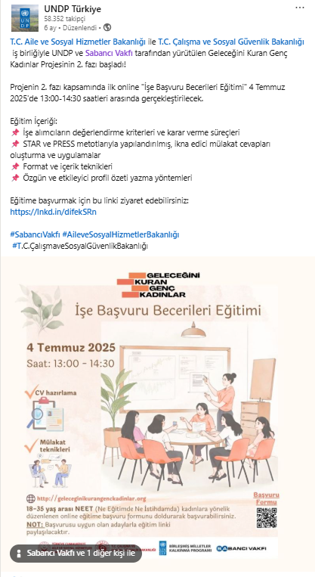
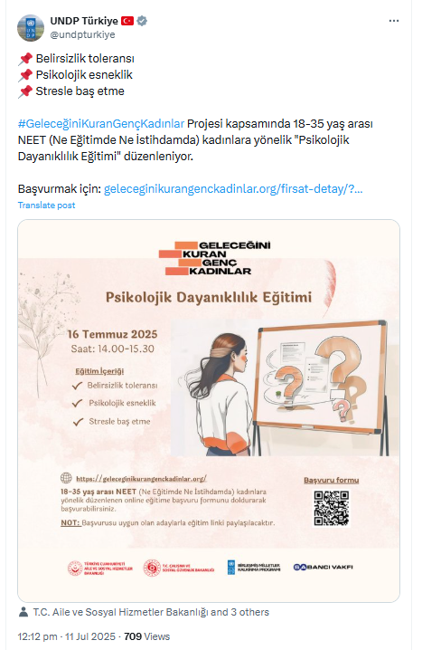

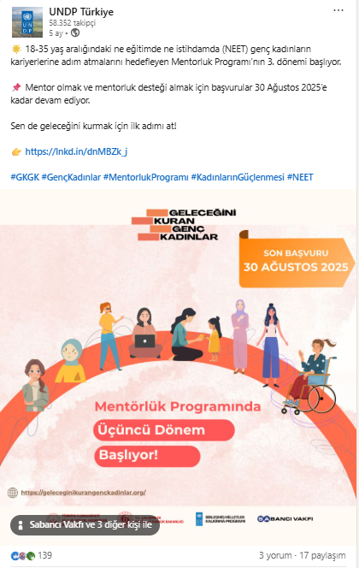
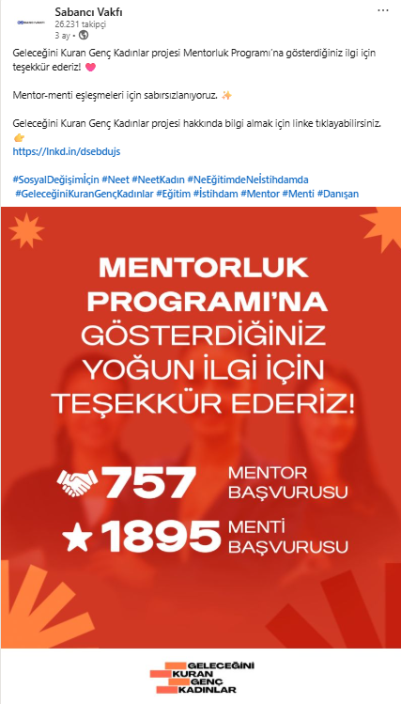

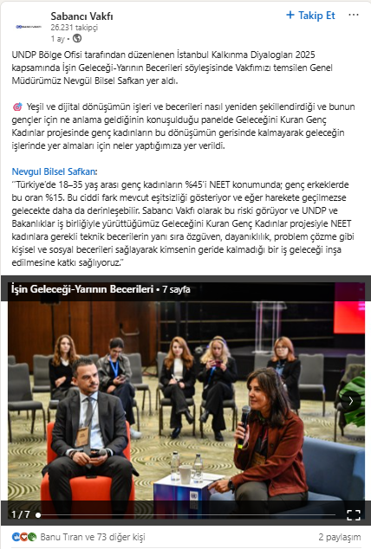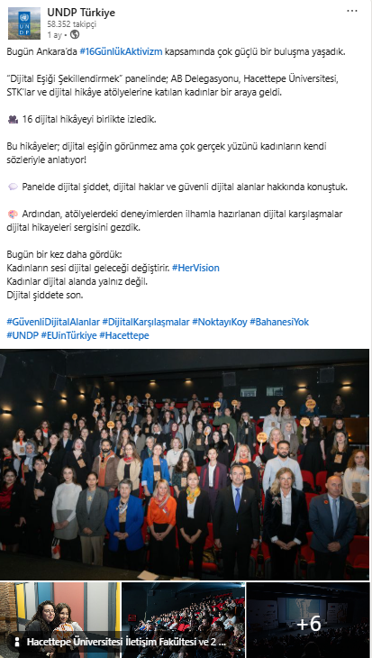

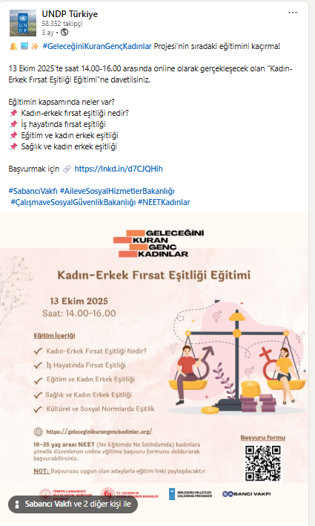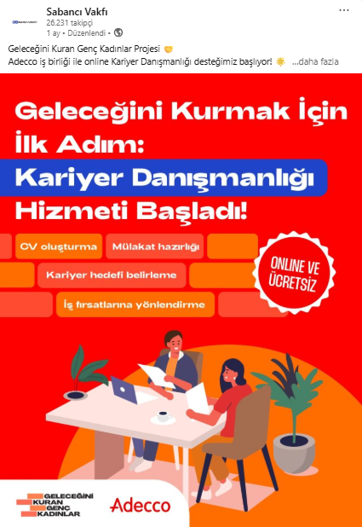
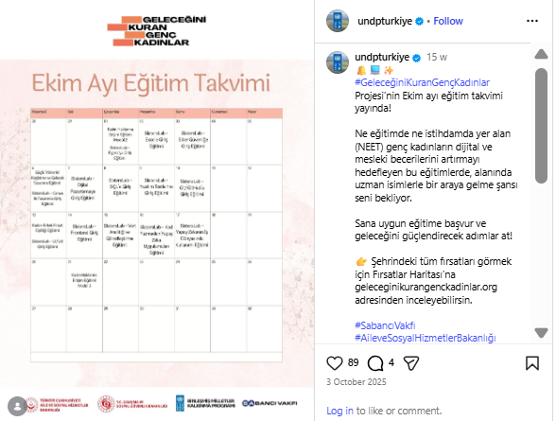

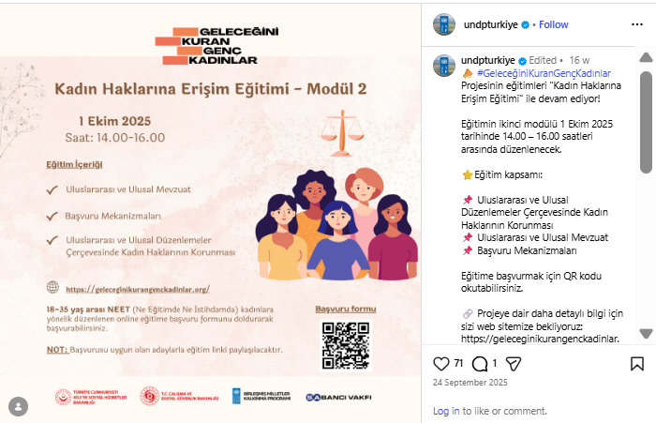
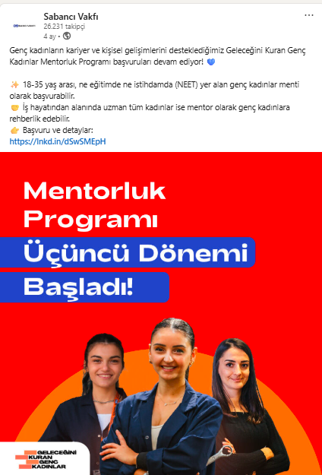
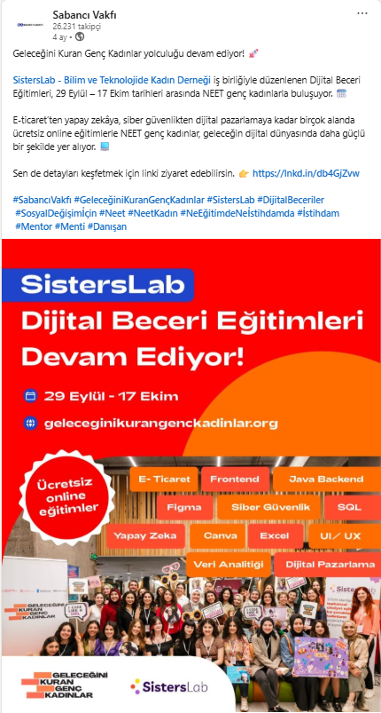
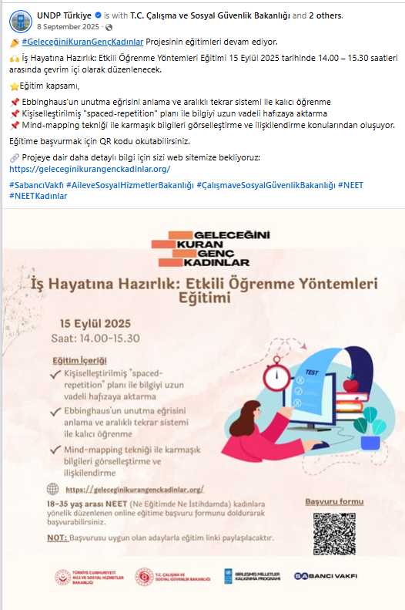

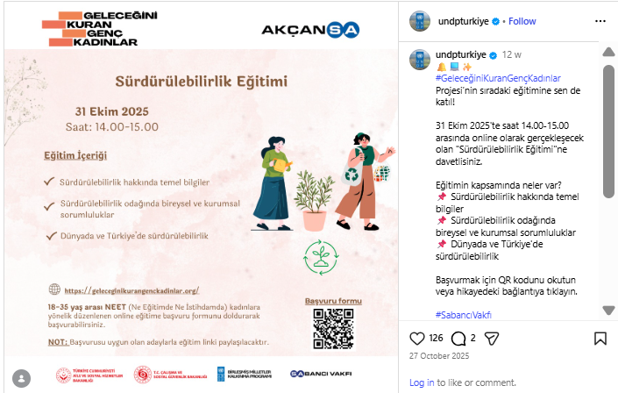

Financial Status

Progress Expenditure Report
Project Name: Young Women Building Their Future Phase II / NEET Women Phase II
Project ID: 01004298 / Period: 01/04/2025 - 20/01/2026
Activity ID | Account | Account Description | Expenditure
ACTIVITY 1 | 72145 | Service Cost - Training and Education Services | 16,350.00
 | 72410 | Information and Communications Technology (ICT) Equipment | 1,560.00
 | 75105 | Facilities and Administration - Implementation | 1,432.80
 | 71620 | Daily Subsistence Allowance - Local | 1,879.76
 | 71635 | Travel Cost - Other | 754.50
 | 72145 | Service Cost - Training and Education Services | 5,300.00
 | 74210 | Printing and Publications | 51.67
 | 74220 | Translation Costs | 171.80
 | 74225 | Other Media Costs | 1,091.37
 | 75105 | Facilities and Administration - Implementation | 927.13
 | 75705 | Learning Costs - Course Fee (non staff) | 2,364.13
 | 76135 | Realized Foreign Exchange Gain - AP | -1.23
 | 76135 | Realized Foreign Exchange Gain - AP | -1.19
ACTIVITY 2 | 72145 | Service Cost - Training and Education Services | 1,877.27
 | 75105 | Facilities and Administration - Implementation | 273.83
 | 75705 | Learning Costs - Course Fee (non staff) | 1,546.02
 | 72315 | Consumables - Food and Textile Products | 434.38
 | 72415 | Courier Charges | 7.42
 | 75105 | Facilities and Administration - Implementation | 35.34
 | 71305 | Local Consultants Expenses - Short-Term Technical Contractors | 4,458.52
 | 72145 | Service Cost - Training and Education Services | 471.18
 | 75105 | Facilities and Administration - Implementation | 394.37
 | 76135 | Realized Foreign Exchange Gain - AP | -5.99
 | 76135 | Realized Foreign Exchange Gain - AP | -2.21
 | 76135 | Realized Foreign Exchange Gain - AP | -7.06
ACTIVITY 4 | 73125 | Common Services - Premises | 178.94
 | 75105 | Facilities and Administration - Implementation | 14.31
 | 71610 | Travel Tickets - Local | 300.47
 | 71620 | Daily Subsistence Allowance - Local | 1,331.32
 | 71635 | Travel Cost - Other | 506.42
 | 75105 | Facilities and Administration - Implementation | 172.28
 | 71475 | Labour Cost - National Personnel Services Agreement | 67,689.65
 | 75105 | Facilities and Administration - Implementation | 5,415.20
 | 74596 | Services to Projects - General Opex | 15,000.00
 | 75105 | Facilities and Administration - Implementation | 1,200.00
 | 76135 | Realized Foreign Exchange Gain - AP | -0,99
Grand Total: |  |  | 133,170.44

Annexes

i.The latest approved Annual Work Plan for the following year (AWP)
iv. Output verification forms completed for monitoring missions
v.Relevant copies of media coverage (a list of media coverage with necessary links would also suffice)
vi.Publications, studies or any other work that is deemed an important output of the project.

If there is any other specific reporting requirements from donors, it can also be inserted here.

EV 1: Meeting Minutes of Project Steering Committee Meeting
EV 2A: Meeting Minutes of İstanbul Metropolitan Municipality/Project Information and Consultation Meeting (internal)
EV 2B: Meeting Minutes of Ankara Metropolitan Municipality/Project Information and Consultation Meeting (internal)
EV 2C: Meeting Minutes of Bursa Metropolitan Municipality Project Information and Consultation Meeting (internal)
EV 2D: Meeting Minutes of Afyonkarahisar Municipality / Project Information and Consultation Meeting (internal)
EV 2E: Meeting Minutes of Kilis Municipality/Project Information and Consultation Meeting (internal)
EV 2F: Minutes of Samsun Metropolitan Municipality Project Information and Consultation Meeting (internal)
EV 2G: Minutes of Bursa Metropolitan Municipality Project Information and Consultation Meeting (internal)
EV 2H: Minutes of Gaziantep Metropolitan Municipality Project Information and Consultation Meeting (internal)
EV 3: İŞKUR Capacity Building Training Signature List
EV 4: Mentorship Program Meeting and Matching Report
EV 5: Career Counseling Program Weekly Report
EV 6: Phase II Training List
EV 7: Phase II List of NEET Women Who Employed
EV 8: Social Media Data (July-December 2025)
EV 9: General Contact List

Ne Eğitimde Ne İstihdamda Yer Alan Genç Kadınlar Mevcut Durum ve İhtiyaç Analizi Araştırması, UNDP Türkiye, Aralık 2022, Ankara.
You should consult your AWP to see what your planned targets were for that year. If this is the final year of your project, you can omit “Annual Target” and only focus on “End of Project Target”.
Disclaimer: Data contained in this financial report section is an extract of UNDP financial records. All financial provided above is provisional. Disclaimer: UNDP adopted IPSAS (International Public Sector Accounting Standards) on 1 January 2012, cumulative totals that include data prior to that date are presented for illustration only.

